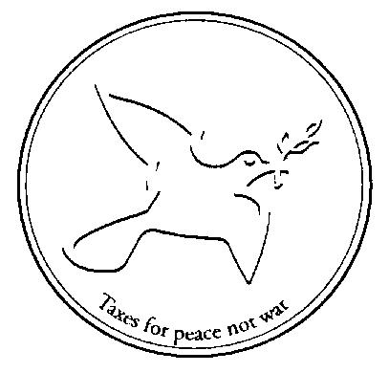
Conscience and Peace Tax International

Human Rights Council
10th Session
2-27 March 2009
Agenda item 3: General Debate

JOINT STATEMENT BY Friends World Committee for Consultation (Quakers) and Conscience and Peace Tax International

Delivered by Rachel Brett, Quaker UN Office, Geneva, on Monday 16 March 2009

CONSCIENTIOUS OBJECTION TO MILITARY SERVICE

FWCC (Quakers) and CPTI welcome the attention given to conscientious objection to military service by the Special Rapporteur on Freedom of Religion or Belief and the Working Group on Arbitrary Detention.

In too many countries, conscientious objectors are still subject to criminal prosecution, and even to repeated punishment for their continued refusal to undertake military service on the same conscientious grounds.

For example, in the report of her Mission to Turkmenistan, the Special Rapporteur on Freedom of Religion or Belief highlights that conscientious objection to military service remains a criminal offence in that country and such objectors may be repeatedly punished contrary to the ne bis in idem principle. We hope that the Government of Turkmenistan will move rapidly to implement her recommendation, and that contained in the report of the Universal Periodic Review, to introduce provision for conscientious objectors, with an alternative civilian service compatible with the reasons for the objection, and revise the provision which enables repeated prosecution of conscientious objectors.

Similarly, the Working Group on Arbitrary Detention not only considers repeated imprisonment of conscientious objectors as arbitrary detention, but also the initial imprisonment since conscientious objectors are seeking to exercise a right which the Human Rights Committee has identified as being protected by Article 18 of the International Covenant on Civil and Political Rights. Whereas in Turkey the detention was under criminal procedures, in Colombia it was by the military themselves. Nevertheless, the Working Group unequivocally found that the practice locally known as “batidas” where young men are rounded up in public places and those who cannot produce their military documentation are immediately incorporated in the army against their will, has no legal basis or juridical support and therefore constitutes arbitrary detention.

In recent years there have been welcome advances in the number of countries which recognise the right of conscientious objection to obligatory military service. By now, over sixty countries have made legislative or constitutional provisions to implement it. Many have also joined the number, now well in excess of 100, which do not impose any obligatory military service in peacetime. There has also been a welcome trend towards the respect of the international standards in the details of the arrangements made for conscientious objectors.

However, three Jehovah's Witnesses who declared themselves conscientious objectors in 1994 are still incarcerated in military detention facilities in Eritrea; and last month, four teenagers attempting to flee the country in order to avoid forced recruitment were summarily shot dead by soldiers. In the Republic of Korea, at the end of December 2008, no less than 432 conscientious objectors were in prison. Recommendations to the Republic of Korea made under the Universal Periodic Review in 2008 included that they “recognize the right of conscientious objection by law, decriminalize refusal of active military service, remove any current prohibition from employment in Government or public organisations and (take) active steps... to introduce alternatives to military service for conscientious objectors.” We welcome statement of the Republic of Korea's Vice-Minister of Foreign Affairs and Trade in the High Level Segment of this Council that “The Republic of Korea is fully committed to the efforts of the international community to make the UPR mechanism more effective... In this regard there is a need for... effective follow-up mechanisms”. We look forward to hearing of the effective follow-up by the Republic of Korea on this recommendation, which was accepted by the Government.

We also encourage the Greek authorities to trace and bring to justice those who on 24 February 2009 threw a hand grenade against the window of a room in which the Greek Conscientious Objectors' movement were holding a public meeting.

Finally, we call on all these Governments, and others where recognition of and provision for conscientious objectors to military service is still a problem, to implement the Concluding Observations of the Human Rights Committee and the Recommendations of the Special Rapporteur on Freedom of Religion or Belief and the Working Group on Arbitrary Detention.

Yeo-Boon Yoon and Myung-Jin Choi v Republic of Korea (CCPR/C/88/D/1321-1322/2004 of 23 January 2007)
UN Working Group on Arbitrary Detention Opinion No.16/2008 (Turkey) of 9 May 2008
UN Working Group on Arbitrary Detention Opinion No.8/2008 (Colombia) of 8 May 2008
The Quaker United Nations Office has prepared a brief summary of these international standards which is available from their website www.quno.org in English, French, Spanish and German.
Paulos Eyassu, Negede Teklemariam and Isaac Mogos: WRI Prisoners for Peace / CO Database http://wri-irg.org/programmes/pfp
CO Update No. 45, February/March 2009 http://wri-irg.org/node/6785
http://ebco-beoc.eu/

