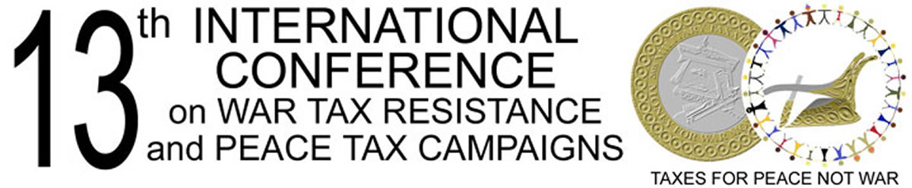

Tributi per la pace, non più per la guerra Kein Geld für Krieg
Geen geld voor geweld Imposto por paco Skatt for fred, ikke for krig
Nos impôts pour la paix Desarma tus impuestos Bakerako zergak, ez gudarako
Taxes for peace, not war

Skiringssal , Norway
2–4 July 2010

To:

A THRIVING DEMOCRACY DESERVES CONSIDERATION OF A PEACE TAX ALTERNATIVE.

2010 is the last year of the United Nations’ International Decade for the Culture of Peace and Non-violence. It will be an important contribution—for peace building and the respect of all individuals—for our government to respond to the peace tax movement’s demand and evaluate and consider the possibility of peace tax.

The peace tax alternative is an extension of the right of conscientious objection to military service:

- based upon Article 18 of the Universal Declaration of Human Rights and
- guaranteed by Article 18 of the International Covenant on Civil and Political Rights and
- guaranteed by Article 9 of the European Convention on Human Rights and Fundamental Freedoms: “freedom of thought, conscience and religion” and
- provided by the national law.

Working for the right not to pay military taxes has a long history, showing that the issue is of fundamental importance.

We look forward to receiving your response.

Conferees of the 13th International Conference on War Tax Resistance and Peace Tax
Campaigns

Please read the enclosed report “Peace Tax 2010 - the Issue, the History, the Movement,” June 2010.
A copy of this letter will also be sent to the various faith communities.

